Functional Requirement Specification (FRS)
For
HENSAP Formula Calculation

Prepared By | Rajoy Rajan
Date | December 17, 2025
Reviewed By | James Mathew
Date | December 18, 2025

Contents
1. Introduction 3
1.1 Purpose 3
1.2 Scope 3
2. Assumptions and Constraints 3
3. Functional Overview 3
4. Functional Requirements 4
FR-1: SAP Formula Association 4
FR-2: Analysis and Component Structure 4
FR-3: SAP Order Number Mapping 4
FR-4: Formula Transformation 4
FR-5: Formula Storage 4
FR-6: Sample Login Behaviour 4
FR-7: Result Entry and Calculation 5
FR-8: Multiple Test Schedule Support 5
FR-9: Calculation Examples 5
FR-10: Workflow Execution 5
FR-11: Automation of Formula Updates 5
FR-12: Manual Maintenance Capability 5
5. Function Design 6
5.1 Disclaimer 6
5.2 Overview 6
5.3 Requirement 7
6. Configuration & Development 9
6.1 Database Updates 9
6.2 C# Task Codes 9
6.3 Workflow Configuration 10
7. Result Entry 11

1. Introduction

1.1 Purpose
The purpose of this Functional Requirements Specification (FRS) is to define the functional requirements for implementing SAP-based formula calculations in the Henkel SampleManager (QCLAD) system.

1.2 Scope
This FRS covers the functional behaviour of:
- SAP formula storage and usage in SampleManager
- Automatic calculation of test results based on SAP formulas
- User interaction during sample login and result entry
- Automation requirements for formula updates

2. Assumptions and Constraints
- Each analysis participating in HenSAP formula calculation will contain only one component.
- SAP formulas will reference components using SAP order numbers.
- HEN_SAP_ORDER_NO should be available for all relevant analyses added to the Test schedule.
- Component List should be added for the analysis that will be calculated.

3. Functional Overview
The system shall:
- Identify test schedules that include SAP formulas
- Store SAP formulas and their SampleManager-compatible equivalent formula
- Automatically calculate results for calculated components

4. Functional Requirements

FR-1: SAP Formula Association
The system shall allow a test schedule to be associated with a SAP formula that defines how a calculated test result is derived.

FR-2: Analysis and Component Structure
The system shall support analyses where:
- Each analysis contains exactly one component
- A calculated analysis derives its result from other analyses

FR-3: SAP Order Number Mapping
The system shall use SAP order numbers to map SAP formula components (e.g., C00010, C00020) to their corresponding analyses in SampleManager.

FR-4: Formula Transformation
When a SAP formula is present in a test schedule, the system shall transform the SAP formula into a SampleManager-compatible formula format.
Example:
- SAP Formula: C00010/C00020
- SampleManager Formula: GET_TEST_RESULT("TEST1","Test1") / GET_TEST_RESULT("TEST2","Test2")

FR-5: Formula Storage
The system shall store:
- The original SAP formula
- A flag indicating the presence of a SAP formula
- The transformed SampleManager-compatible formula

FR-6: Sample Login Behaviour
During sample login, when a test schedule contains a SAP formula:
- The system shall identify the calculated analysis
- The component data type shall be treated as Calculated
- The calculation formula shall be assigned automatically

FR-7: Result Entry and Calculation
When a user enters results for input tests:
- The system shall automatically calculate the result for the calculated test
- The calculated result shall not require manual user entry

FR-8: Multiple Test Schedule Support
The system shall support different SAP formulas for different test schedules, even when the same analyses are used.

FR-9: Calculation Examples
The system shall calculate results as follows:
HEN_TS1
- Formula: Test1 / Test2
- Input: Test1 = 4, Test2 = 14
- Result: 0.28
HEN_TS2
- Formula: (88/24) * Test2
- Input: Test2 = 10
- Result: 36.66

FR-10: Workflow Execution
The system shall ensure that calculated formulas are evaluated during result entry within the test workflow.

FR-11: Automation of Formula Updates
The system shall support automated updating of SAP-related formula fields to minimize manual maintenance.

FR-12: Manual Maintenance Capability
The system shall allow authorized users to manually trigger formula updates when required.

5. Function Design

5.1 Disclaimer
The screenshots shown in this document are provided solely for Proof-of-Concept purposes. The final system design may differ from the screenshots illustrated. All data displayed in the screenshots is sample data and does not represent actual system data; it is included for reference only

5.2 Overview
For the Henkel QCLAD system, Analysis and Test Schedule data will be populated from SAP. Each Analysis will contain only one component, and the component result type will be Numeric.
The following example illustrates how an Analysis and its corresponding Component will be configured:

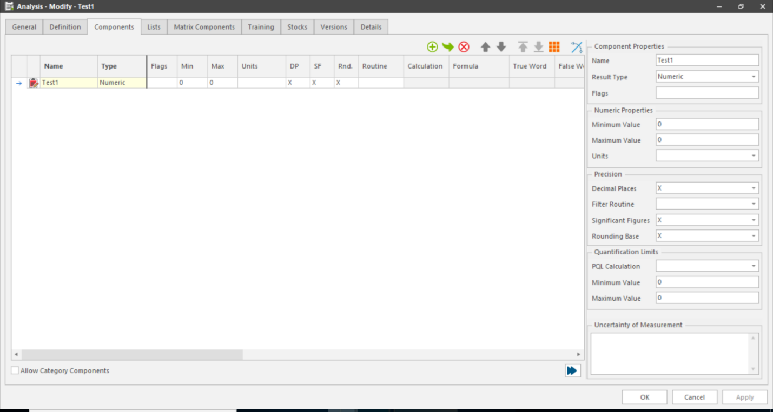

Below is an illustration of how test schedules are configured. Each analysis must have a HEN_SAP_ORDER_NO defined, and the analysis used for calculation must have the SAP formula populated in HEN_SAP_FORMULA
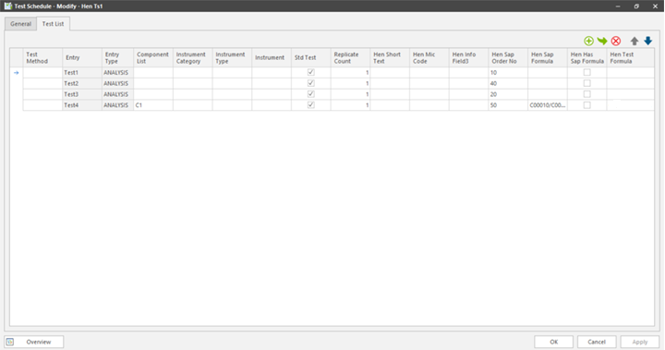

5.3 Requirement
For a calculation to be executed on the SampleManager result entry screen, the component shall have its result type set to Calculated and shall be associated with either a formula created using the SampleManager in-built formula builder or a valid VGL calculation code.
Since Henkel formulas are sourced from SAP and populated at the test schedule level, and the formula is based on the HEN_SAP_ORDER_NO, the system shall convert the SAP formula into a SampleManager-compatible format.
For example, if the HEN_SAP_FORMULA is defined as C00010/C00020, the system shall convert it to:
GET_TEST_RESULT("TEST1","Test1") / GET_TEST_RESULT("TEST2","Test2")
where C00010 represents the result entered for analysis TEST1 (component Test1) and C00020 represents the result entered for analysis TEST2 (component Test2).
To support this functionality, additional fields shall be added to the TEST_SCHEDULE and TEST tables.

The conversion of the SAP formula into a SampleManager-compatible format may be performed using one of the following mechanisms:
1. Manual updating of the HEN_TEST_FORMULA field.
2. Automatic execution via a scheduled background task at a predefined time interval.
3. On-demand execution by manually triggering a task from within the SampleManager application when required.
Once updated, the formula can be viewed on the Test Schedule Data Entry screen, as illustrated below.
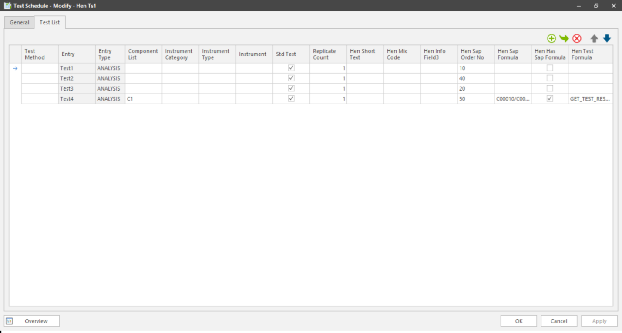

The EXTENDED_HENKEL_TEST workflow shall be enhanced by introducing a conditional check within the Post Login event. This condition will evaluate whether the test has the HEN_HAS_SAP_FORMULA flag set to true. When the condition is met, the system shall set the result type to Calculated and copy the corresponding formula from the Test level to the Result level.
The ability to dynamically change the result type from Numeric to Calculated is a Henkel-specific requirement. This is necessary because, depending on the business scenario, the result for a given analysis may be manually entered in some cases, while in other cases it must be automatically calculated based on the results of other analyses

6. Configuration & Development

6.1 Database Updates
Two new fields shall be added to the TEST_SCHEDULE and TEST tables. The table below describes the required fields to be added.
No. | Field Name | Data Type | Description
1 | hen_has_sap_formula | Identity | This flag shall be used by the workflow to determine whether the result type should be set to Calculated and whether the corresponding formula should be updated in the Result table.
2 | hen_test_formula | Text | The field holding the equivaled SampleManager formula

6.2 C# Task Codes
Due to limitations in manual data entry within the Henkel system, the update of HEN_TEST_FORMULA based on the logic defined in HEN_SAP_FORMULA shall be automated. This automation shall be implemented using C# tasks to ensure consistency, accuracy, and reduced manual effort.
The proposed solution shall include a background task configured within the Watchdog Timer, as well as an on-demand task that can be manually executed from within the SampleManager application when required. To support these execution modes, two separate task implementations shall be developed:
- HenSapFormulaToTestFormulaBG – Background task executed via the Watchdog Timer
- HenSapFormulaToTestFormula – On-demand task manually triggered within SampleManager
The automation logic shall perform the following steps:
- Identify all test schedules that contain a populated HEN_SAP_FORMULA
- Convert the SAP formula into a SampleManager-compatible format
- Populate the converted value into HEN_TEST_FORMULA
- Set the HEN_HAS_SAP_FORMULA flag to true
The scheduled background task shall be configured to execute on a weekly basis, ensuring that all relevant test schedule entries are updated automatically and maintained consistently over time.

6.3 Workflow Configuration

When a sample is logged in with an associated Test Schedule, additional logic shall be executed within the EXTENDED_HENKEL_TEST workflow during the Post Login event. The workflow shall evaluate whether the analysis has the HEN_HAS_SAP_FORMULA flag set to true.
When this condition is satisfied, the system shall automatically set the result type to Calculated and copy the corresponding formula from the Test level to the Result level. This ensures that the calculated result is correctly derived during result entry based on the defined SAP formula.
An example of the updated workflow behavior is illustrated below.

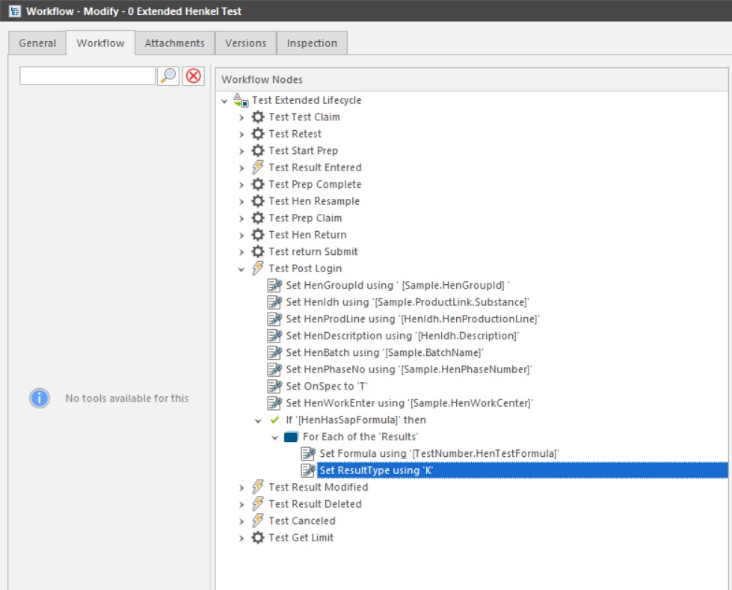

7. Result Entry

When a user enters results for input tests:
- The system shall automatically calculate the result for the calculated test after clicking enter button.
- The calculated result shall not require manual user entry .
- This automatic result entry will be applicable for Instrument based result entry .
- Clicking on recalculate option also will provide the calculated results.

